Spatial Patterns of Bus Arrival Reliability in San Francisco Using GTFS and Real-Time Data

Abstract
This report evaluates bus arrival reliability in San Francisco using scheduled GTFS times and real-time arrivals collected during October–November 2025. The analysis covers 3,225 stops. Service intensity is uneven across the city. High-frequency corridors concentrate on the eastern and northeastern side. Many stops receive around 30–60 arrivals per day, while a small set exceeds 150 and reaches roughly 300.
Arrival deviations are split into early and late events. Both occur frequently, and both are strongly right skewed. Most early arrivals are only a few minutes early, but rare events are much larger. Early patterns are dispersed across the network and do not form one dominant hotspot. Late arrivals show a clearer spatial structure. The northeastern part of the city has many stops with larger mean lateness, and the late-delay distribution has a long tail.
On-time performance is computed using a 5-minute threshold. The system centers around ~40% on-time performance, with wide variation across stops. Higher reliability is more common in the west, even where service frequency is lower. Overall, the figures show strong spatial heterogeneity in both service intensity and reliability, with the northeastern corridors standing out as a persistent delay hotspot.

Results and Discussion
This study evaluates bus service reliability in San Francisco using scheduled General Transit Feed Specification (GTFS) data and real-time (RT) arrival observations [1]. San Francisco has an estimated population of 0.9 million and a population density of approximately 19,000 persons per square mile, with public transit accounting for roughly 30% of all trips as shown in Figure 1 [2]. The analysis includes 3,225 bus stops across the city. Real-time arrival data were collected over a 24-day period during October and November 2025. Arrival delays are computed as the difference between scheduled GTFS arrival times and observed RT arrivals.
Service intensity is quantified using stop-level daily arrival frequency. Spatial patterns show that routes connecting the southern and northeastern regions of the city experience substantially higher service levels than routes in the western region as shown in Figure 2. Across the network, the mean arrival frequency is approximately 50 buses per stop per day, while high demand stops exceed 300 arrivals per day as shown in Figure 3. Arrival frequency is defined as the number of buses serving a stop per day per travel direction.
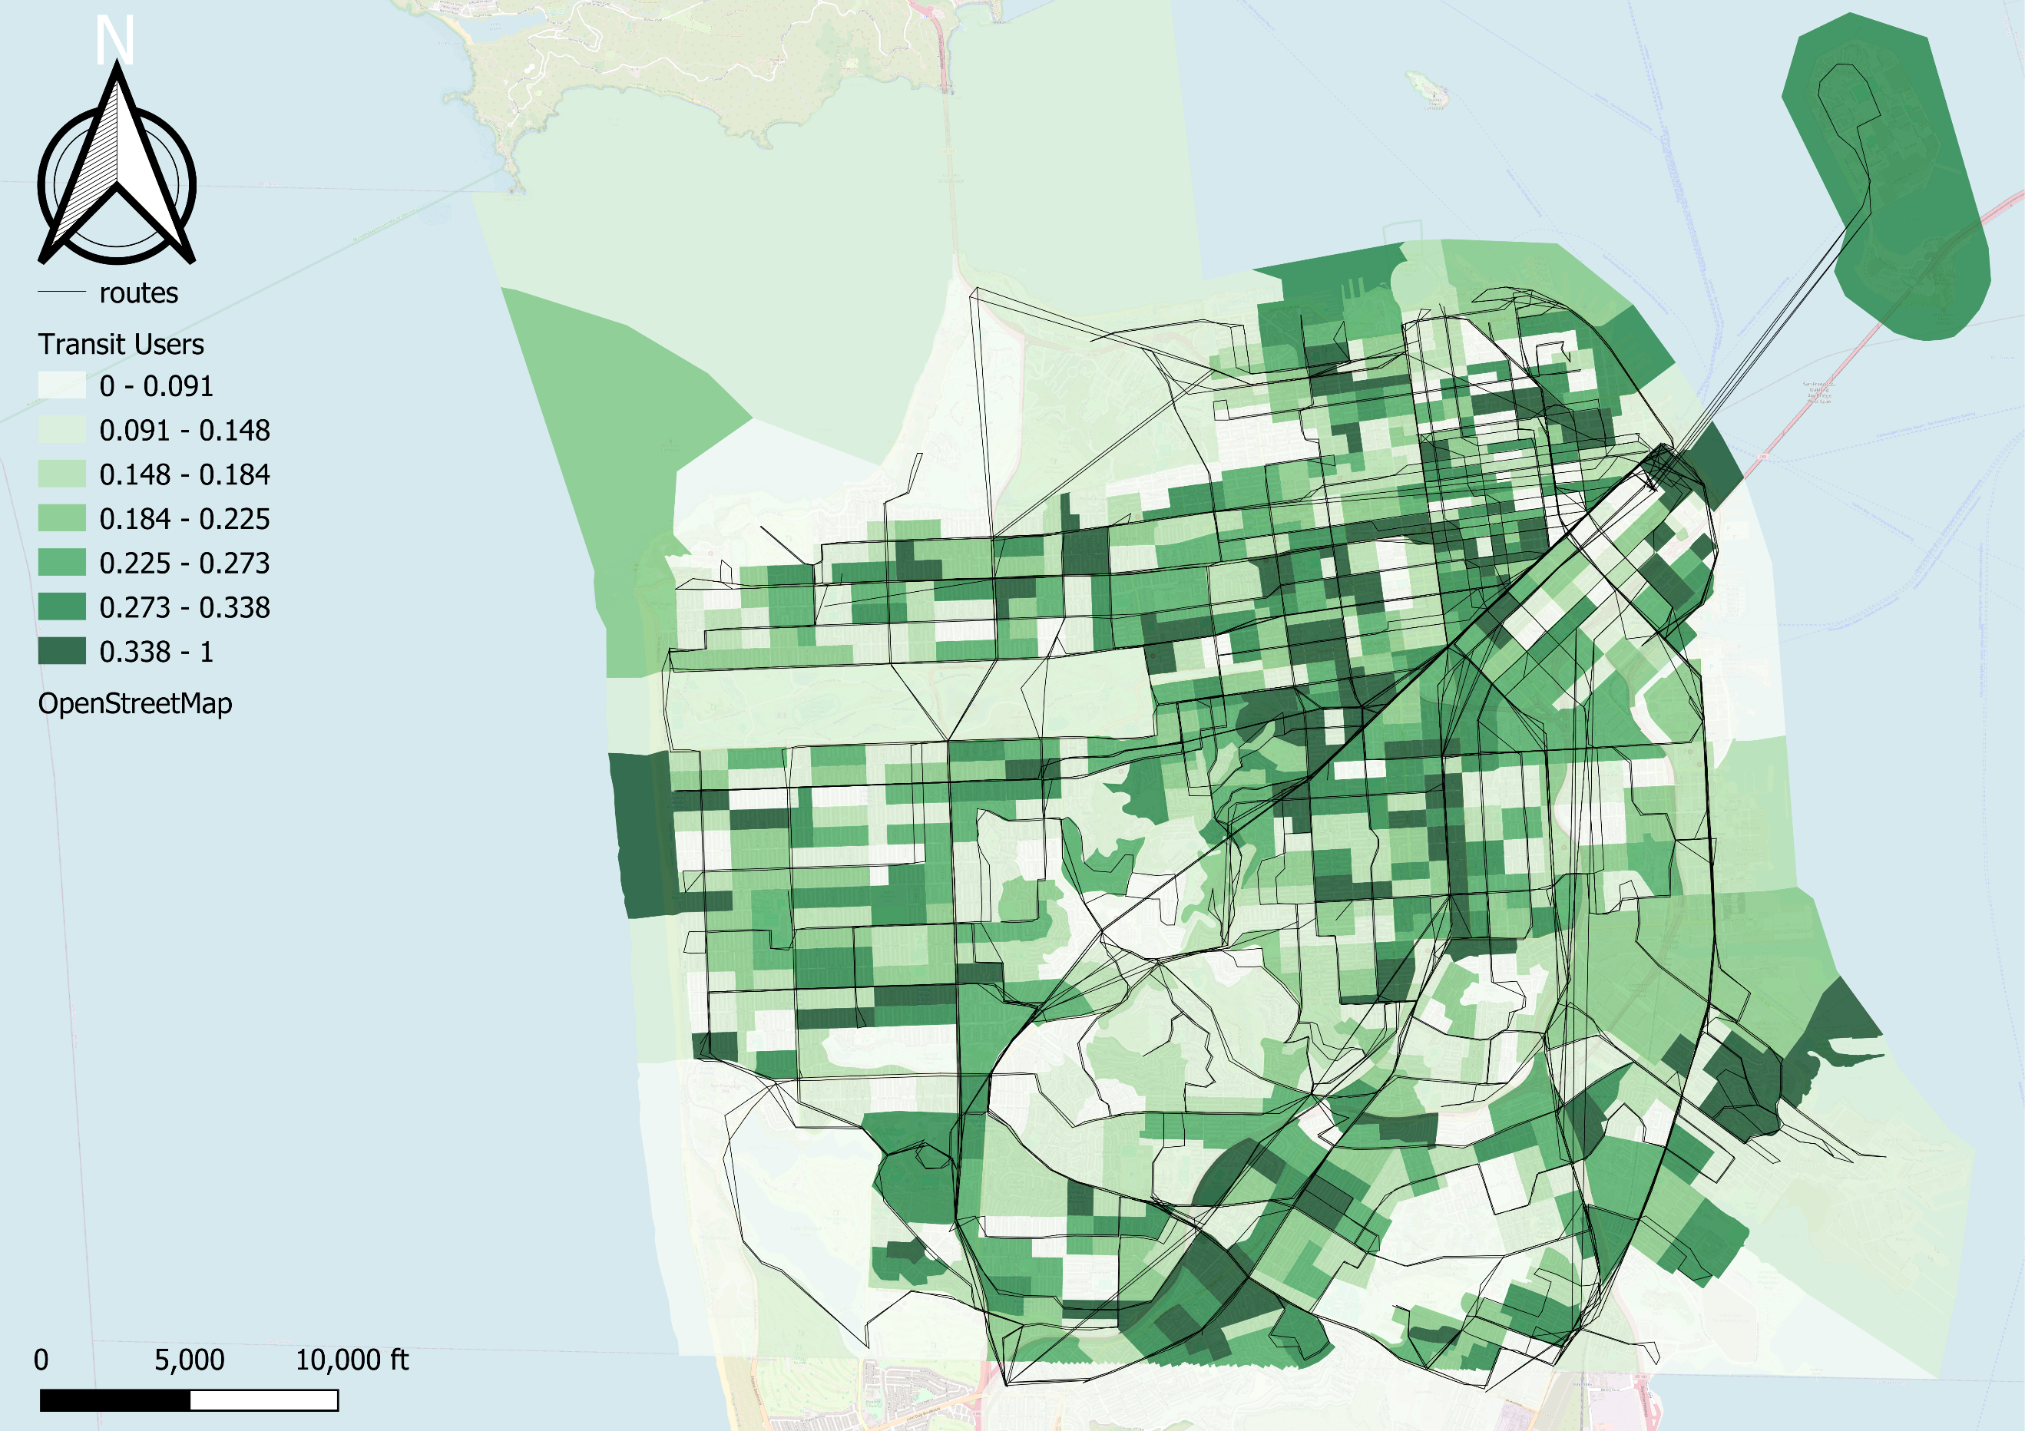
Figure 1 Proportion of public transit users in San Francisco
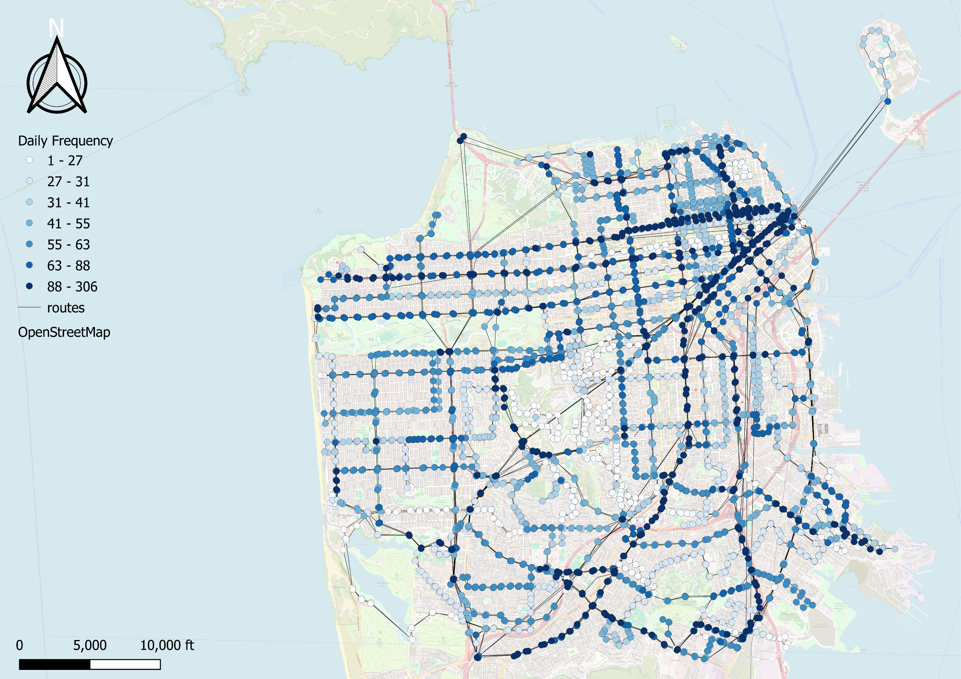
Figure 2 Spatial distribution of daily bus arrival frequency at each stop in San Francisco. Colors represent the average number of bus arrivals per stop per day per direction.
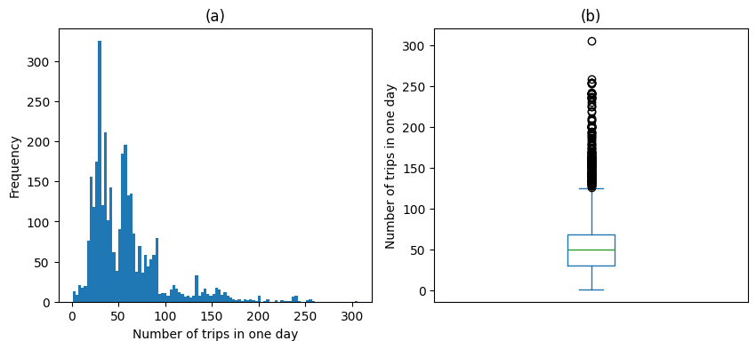
Figure 3 Statistical distribution of daily bus arrival frequency across all stops in San Francisco: (a) histogram showing the right-skewed distribution of stop-level daily arrivals and (b) boxplot summarizing central tendency and extreme high-frequency stops.
Early and late arrivals occur at nearly equal frequencies, as shown in Figure 5 and Figure 7, indicating that buses in San Francisco are equally likely to arrive ahead of or behind schedule. Early arrivals follow a strongly right-skewed (exponential) distribution. Most early events are within approximately two minutes of the scheduled time, although rare cases exceed 10 minutes as shown in Figure 5. Figure 4 shows that spatially, stops experiencing large early arrivals are not concentrated in a single region of the city. When compared with the service frequency map (Figure 2), lower-frequency routes appear less likely to experience early arrivals than high-frequency corridors.
While the mean delay across all arrivals at a stop is expected to be close to zero, this symmetry does not hold when late arrivals are examined separately. When only late events are considered, buses are delayed by an average of approximately two minutes as shown in Figure 7. Late arrivals also exhibit an exponential distribution, with most delays being small but a long tail extending to delays of up to 20 minutes. Unlike early arrivals, late delays show a clearer spatial pattern. The northeastern region of the city consistently exhibits higher average lateness than other areas (Figure 6).
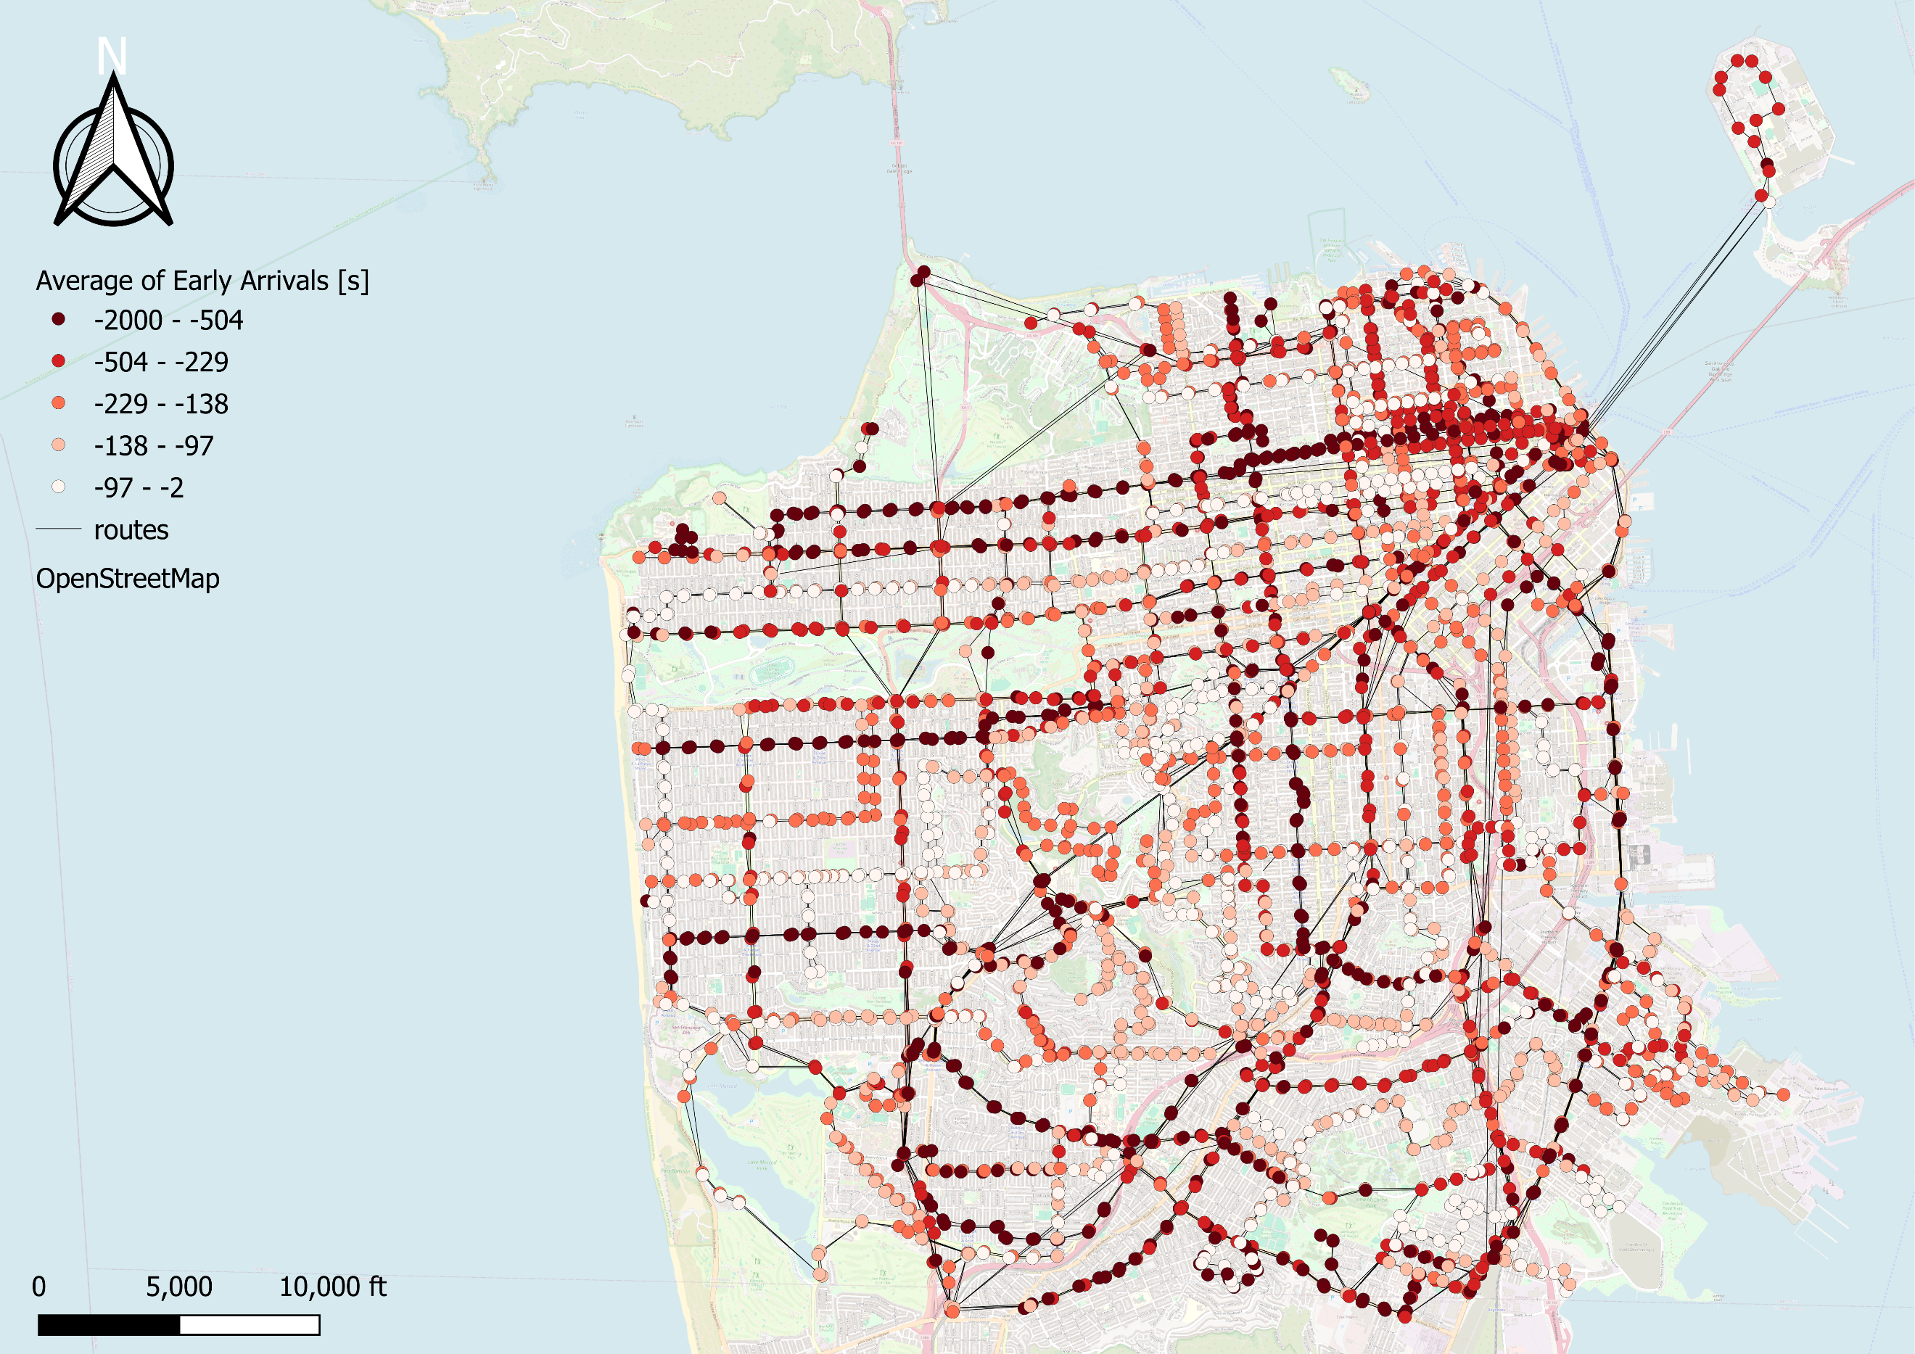
Figure 4 Spatial distribution of mean early arrival time at each stop in San Francisco. Values represent the average number of minutes buses arrive earlier than scheduled, computed only for early arrival events.
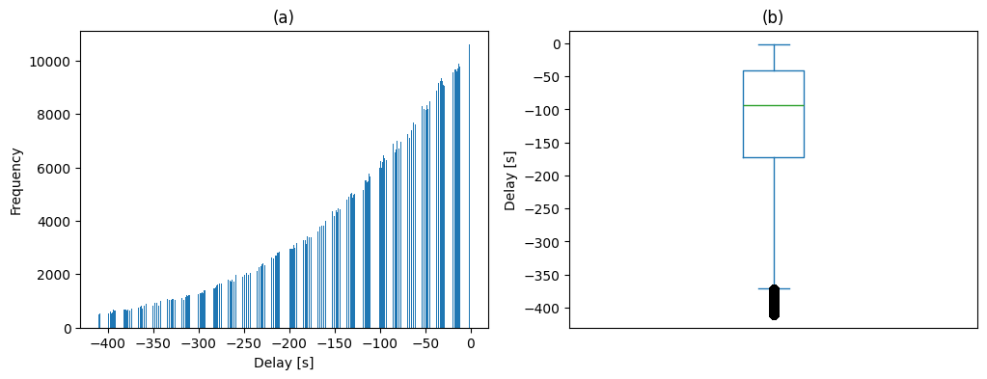
Figure 5 Distribution of early arrival times across the transit network: (a) histogram showing the exponential decay of early arrival magnitudes and (b) boxplot illustrating the concentration of most events within a few minutes and the presence of extreme early arrivals.
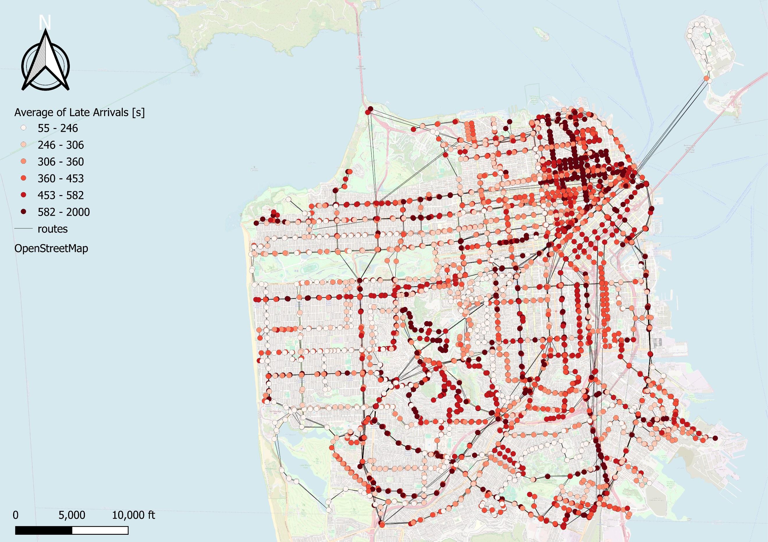
Figure 6 Spatial distribution of mean late arrival time at each stop in San Francisco. Values represent the average delay in minutes, computed only for late arrival events, highlighting regions with persistent lateness.
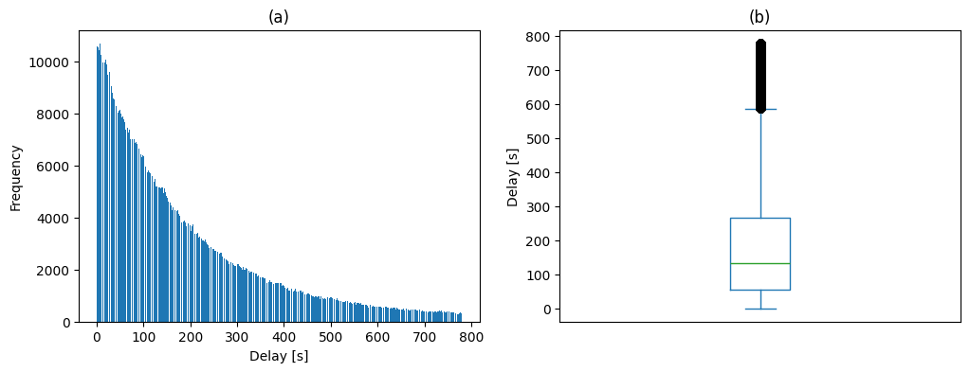
Figure 7 Distribution of late arrival times across the transit network: (a) histogram showing a right-skewed distribution of delays and (b) boxplot summarizing typical delays and extreme late-arrival events.
On-Time Performance (OTP) is computed for each stop using Equation (1), with higher values indicating better schedule adherence. The system-wide average OTP is approximately 40%, as shown in Figure 9. This indicates that only four out of ten bus arrivals occur within the 5-minute acceptable time window, while the remaining arrivals are either early or too late. Spatial patterns in Figure 8 reveal higher OTP values in the western part of the city, indicating comparatively better service reliability in that region. However, these areas also exhibit lower service frequency, as shown in Figure 2.
Given San Francisco’s population of over 0.9 million, a population density of approximately 19,000 persons per square mile, and a public transit mode share of about 35%, an average OTP of 40% reflects the operational challenges of maintaining schedule adherence in a high-demand urban network. Nevertheless, the results indicate substantial room for improvement, particularly along the highest-frequency corridors where delays are most persistent.

 | $$OTP=\frac{N_{5}}{N} ×100$$ | (1)
Where $N_{5}$ is the number of arrivals that are neither early nor late by more than five minutes and $N$ is the total arrivals for that stop.
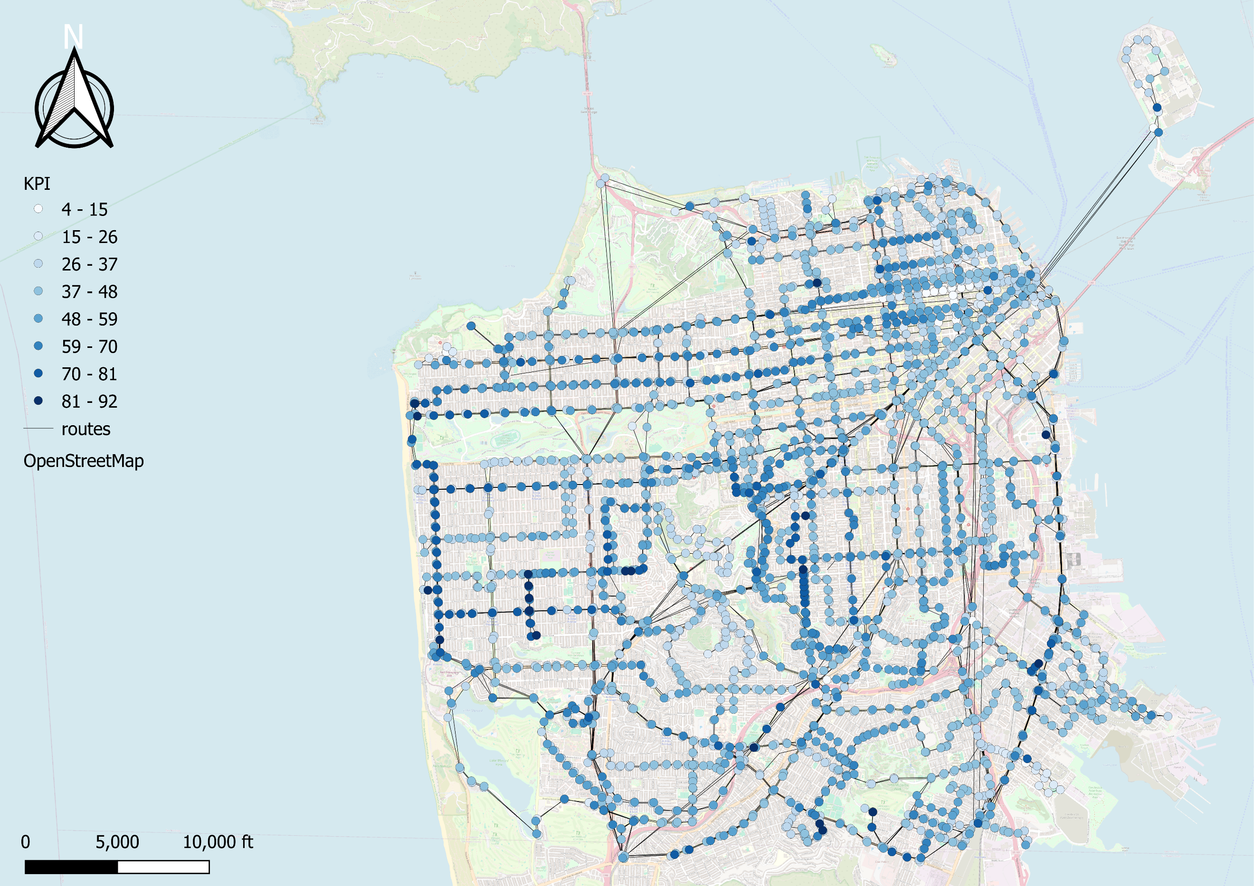
Figure 8 Spatial distribution of stop-level On-Time Performance (OTP) in San Francisco using a 5-minute threshold. Higher values indicate a greater fraction of arrivals occurring within the acceptable time window.
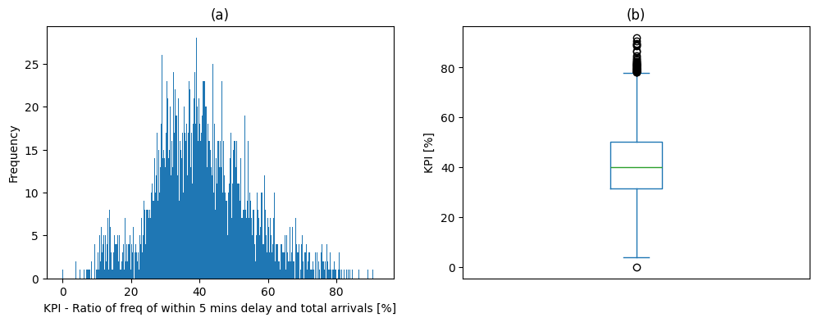
Figure 9 System-wide distribution of On-Time Performance (OTP) across all stops in San Francisco: (a) histogram showing the overall concentration of OTP values around 40% and (b) boxplot illustrating variability and outliers across the network.

Conclusion
This study examined bus service reliability in San Francisco using scheduled GTFS data and real-time arrival observations collected during October and November 2025. Analysis of stop-level service frequency revealed strong spatial heterogeneity, with the highest service intensity concentrated along corridors connecting the southern and northeastern parts of the city. Arrival deviations showed that early and late arrivals occur with similar frequency, and both follow strongly right-skewed distributions. While most deviations are small, rare extreme events contribute substantially to overall unreliability.
Spatial patterns differ between early and late arrivals. Early arrivals are broadly dispersed across the network and mostly follow the same pattern as the service frequency, whereas late arrivals are more spatially concentrated, particularly in the northeastern region. On-Time Performance further highlights these disparities. The system-wide average OTP of approximately 40% indicates that fewer than half of all arrivals occur within the acceptable time window, with higher reliability observed in lower-frequency western areas.
Overall, the results demonstrate that service reliability is not solely a function of schedule adherence but is strongly linked to spatial variations in demand and service intensity. Improving reliability in high-frequency corridors should therefore be a priority, as targeted operational adjustments in these areas are likely to yield the greatest system-wide benefits.

References
[1] “Transit Data.” Accessed: Dec. 15, 2025. [Online]. Available: https://511.org/open-data/transit
[2] “Census Bureau Data.” Accessed: Dec. 15, 2025. [Online]. Available: https://data.census.gov/

